**Project Proposal for Participatory Budget Fund 2025**

**Our Charity**

At ESOLPerth, we are a dedicated charity committed to teaching English to anyone eager to learn and begin their life in a new country. Our mission is to empower individuals, particularly refugees and asylum seekers, with the language skills they need to navigate daily life, build confidence, and thrive in their new communities.

We proudly serve students from 27 different nationalities, creating a vibrant and inclusive learning environment that celebrates diversity. Our work is built on four key pillars:

1. **English Language** – Providing tailored classes to help learners at all levels improve their communication skills.
2. **Advocacy** – Offering guidance and support to help students overcome challenges related to immigration, housing, and employment.
3. **Well-being** – Fostering mental and emotional health by addressing social isolation and creating a supportive community.
4. **Community Support** – Encouraging social inclusion and cultural exchange through events, activities, and practical assistance.

At ESOLPerth, we believe that language is the key to unlocking opportunities and building a brighter future. Together, we create a warm, welcoming space where individuals can connect, grow, and flourish.

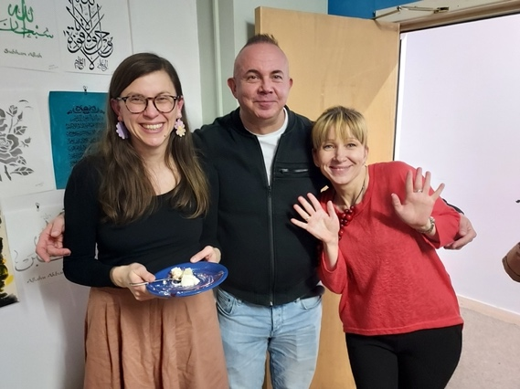 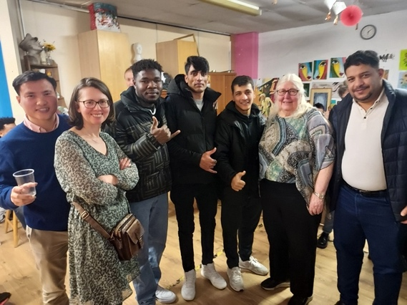

**Our project**

We work tirelessly to empower refugees, asylum seekers, and other vulnerable individuals to rebuild their lives in a foreign land. Through consistent engagement with our students and service users, we have identified a pressing need many of them are battling poverty due to unemployment. A significant number of new refugees have recently joined our society with little to no knowledge of how to access employment opportunities. Despite their eagerness to work and contribute, they lack the skills, confidence, and awareness needed to secure jobs.

To address this challenge, we are launching the "Job Club” project, a program exclusively designed to equip refugees and asylum seekers with the essential skills and confidence to enter the workforce. This initiative will provide a structured pathway to employment through tailored workshops, practical training, and one-on-one support.

**Objectives**

1. To teach key employability skills such as CV writing, interview techniques, and job search strategies.
2. To build participants’ confidence through soft-skills training, including communication, teamwork, and problem-solving.
3. To provide guidance on navigating the job market, including understanding workplace culture and labor laws.
4. To foster connections with local employers and create opportunities for work placements or apprenticeships.

**Activities**

* Weekly classes on employability skills.
* Mock interviews and practice sessions.
* Digital literacy training for job applications and online communication.
* Networking events with local employers and recruitment agencies. We regularly work with Street League, Search, and Graham Hygiene. Our in-house Admin Officer supports our students with searching for jobs on job boards, applying for suitable jobs, and writing CVs.
* Ongoing mentorship and support to help participants sustain employment.

**Expected Outcomes**

1. Increased employability among refugees and asylum seekers.
2. Improved confidence and self-reliance in navigating the job market.
3. Strengthened connections between employers and the refugee community.
4. Reduction in poverty levels within the community

**Budget**

The first phase of the project will be run for 24 weeks.

Expected Start Date: 10th March 2025

Expected Finish Date: 03rd October 2025

|  |  |  |
| --- | --- | --- |
| **Item** | **Description** |  |
| Workshop conducting cost | £30 per hour x 2 hours a day x 4 days a week x 24 weeks | **£5,760.00** |
| One to one Mentoring | £20 per hour x 3 hours a day x 2 days a week x 24 weeks | **£2,880.00** |
| Venue cost | £25 per session x 4 days a week x 24 weeks | **£2,400.00** |
| Material Cost | One Off | **£300.00** |
| Total |  | **£11,340.00** |

**Conclusion**

In conclusion, this employment program plays a crucial role in facilitating the social integration of New Scots by equipping them with valuable skills and connecting them with the local community. By fostering inclusivity and showcasing their talents, the project contributes to building a stable, thriving, and diverse society. Through meaningful employment opportunities, it empowers asylum seekers and refugees to achieve self-sufficiency while enriching the cultural and economic fabric of the community.