The Impact – ymca tayside eco ambassador programme

* The young people will experience an increase in confidence and self-esteem, increased knowledge and awareness of climate challenge and how to address this, increased enthusiasm and passion for climate change and environmental awareness, increased social and emotion skills, increased friendships with peers, increased communication, teamwork and presentation skills.
* As a registered SQA centre young people have a flexible and creative educational pathway for them to gain accreditation and increase their skillset. Through involvement in the project, young people will be able to work towards new qualifications such as: Hi5 awards and Dynamic Youth Awards, Micro Credentials, Saltire Awards, Climate Awareness Training and HP Life Awards. At the Youth Summit event they will also receive recognition for their efforts and hopefully be able to receive a Keep Scotland Beautiful Award.

**Next Steps:**

* Currently we are building a new Y-Centre for young people. The centre includes space for young people to participate in opportunities to develop Life skills and skills for work through training academies in the Outdoors, Barista and Construction. There will also be opportunities to develop business skills in STEAM/Digital. The new Y Centre improves our ability to offer and enhance opportunities available to young people and our partner organisations.
* Increasing social inclusion, we can provide general Drop In warm spaces with access to internet, computers, food and youth workers. The new Y-Centre also includes 8 flats specifically for young people that the young people on this project can access. The flats will be used for a ‘time out’ from living with the family to allow for mediation to restore relationships rather than young people becoming homeless and entering the system, as well as a transition flat for longer periods of time before gaining their own long-term accommodation.
* YMCA are also able to mediate and broker on the behalf of the young people, offering advocacy and standing up for their rights. This also can have a positive impact on the young person’s family life and wider community.

CASE STUDY

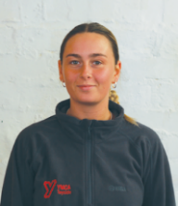Layla has been involved with YMCA Tayside for 9 years, first as a young person attending youth club all the way to now being a part time youth worker for the last 2 years (30 hours per week).

Layla, by example is inspiring young people daily in her role, demonstrating that you can achieve your dreams/goals and find a job that you love and are passionate about. Over the last 18months Layla has taken on many responsibilities in the YMCA, most significantly leading the very youth club as a church partnership that she first became involved in. Layla oversees a very successful weekly youth club.

She manages a great team of sessional staff and volunteers, where they deliver a high energy youth club for 20 – 30 young people. Layla has also stepped into a leadership role in our YMCA Youth Voice where she is now chairing the meetings and helping keep the team of 6 young adults on track to achieving their goals.

Within Voice Layla was instrumental in delivering a Youth Led conference to over 60 attendees, from the local council, third sector and predominantly young people. Layla spoke confidently and boldly on key topics such as mental health, discrimination and climate change, she even managed to get the CEO of the council to be the key note speaker.

Layla also stepped out of her comfort zone and demonstrated more inspiring leadership this summer by attending the YMCA World Council on behalf of the youth led solutions team, working in an international team over several months on a mini project that they then gave feedback on at the World Council.

Layla demonstrated leadership skills in Poland this summer, working at a summer camp with 50 young people, delivering english lessons, sports events, quiz nights and Scottish themed events.

Layla has also been instrumental in supporting and speaking at National Initiatives on behalf of YMCA for Youthlink Scotland, ie Careers by design and Youth Employability. She has also been successful in gaining a key leadership position on the youth funding panel with The Gannochy Trust.

**Link below to a video that highlights Layla’s incredible journey.**

[**https://youtu.be/lFyKpkxOZ4Y?si=5-G6AnkoCUiuO5q7**](https://youtu.be/lFyKpkxOZ4Y?si=5-G6AnkoCUiuO5q7)

our work

Our Strategic Priorities over the next 7 years (2023 – 2030) come under 4 pillars:

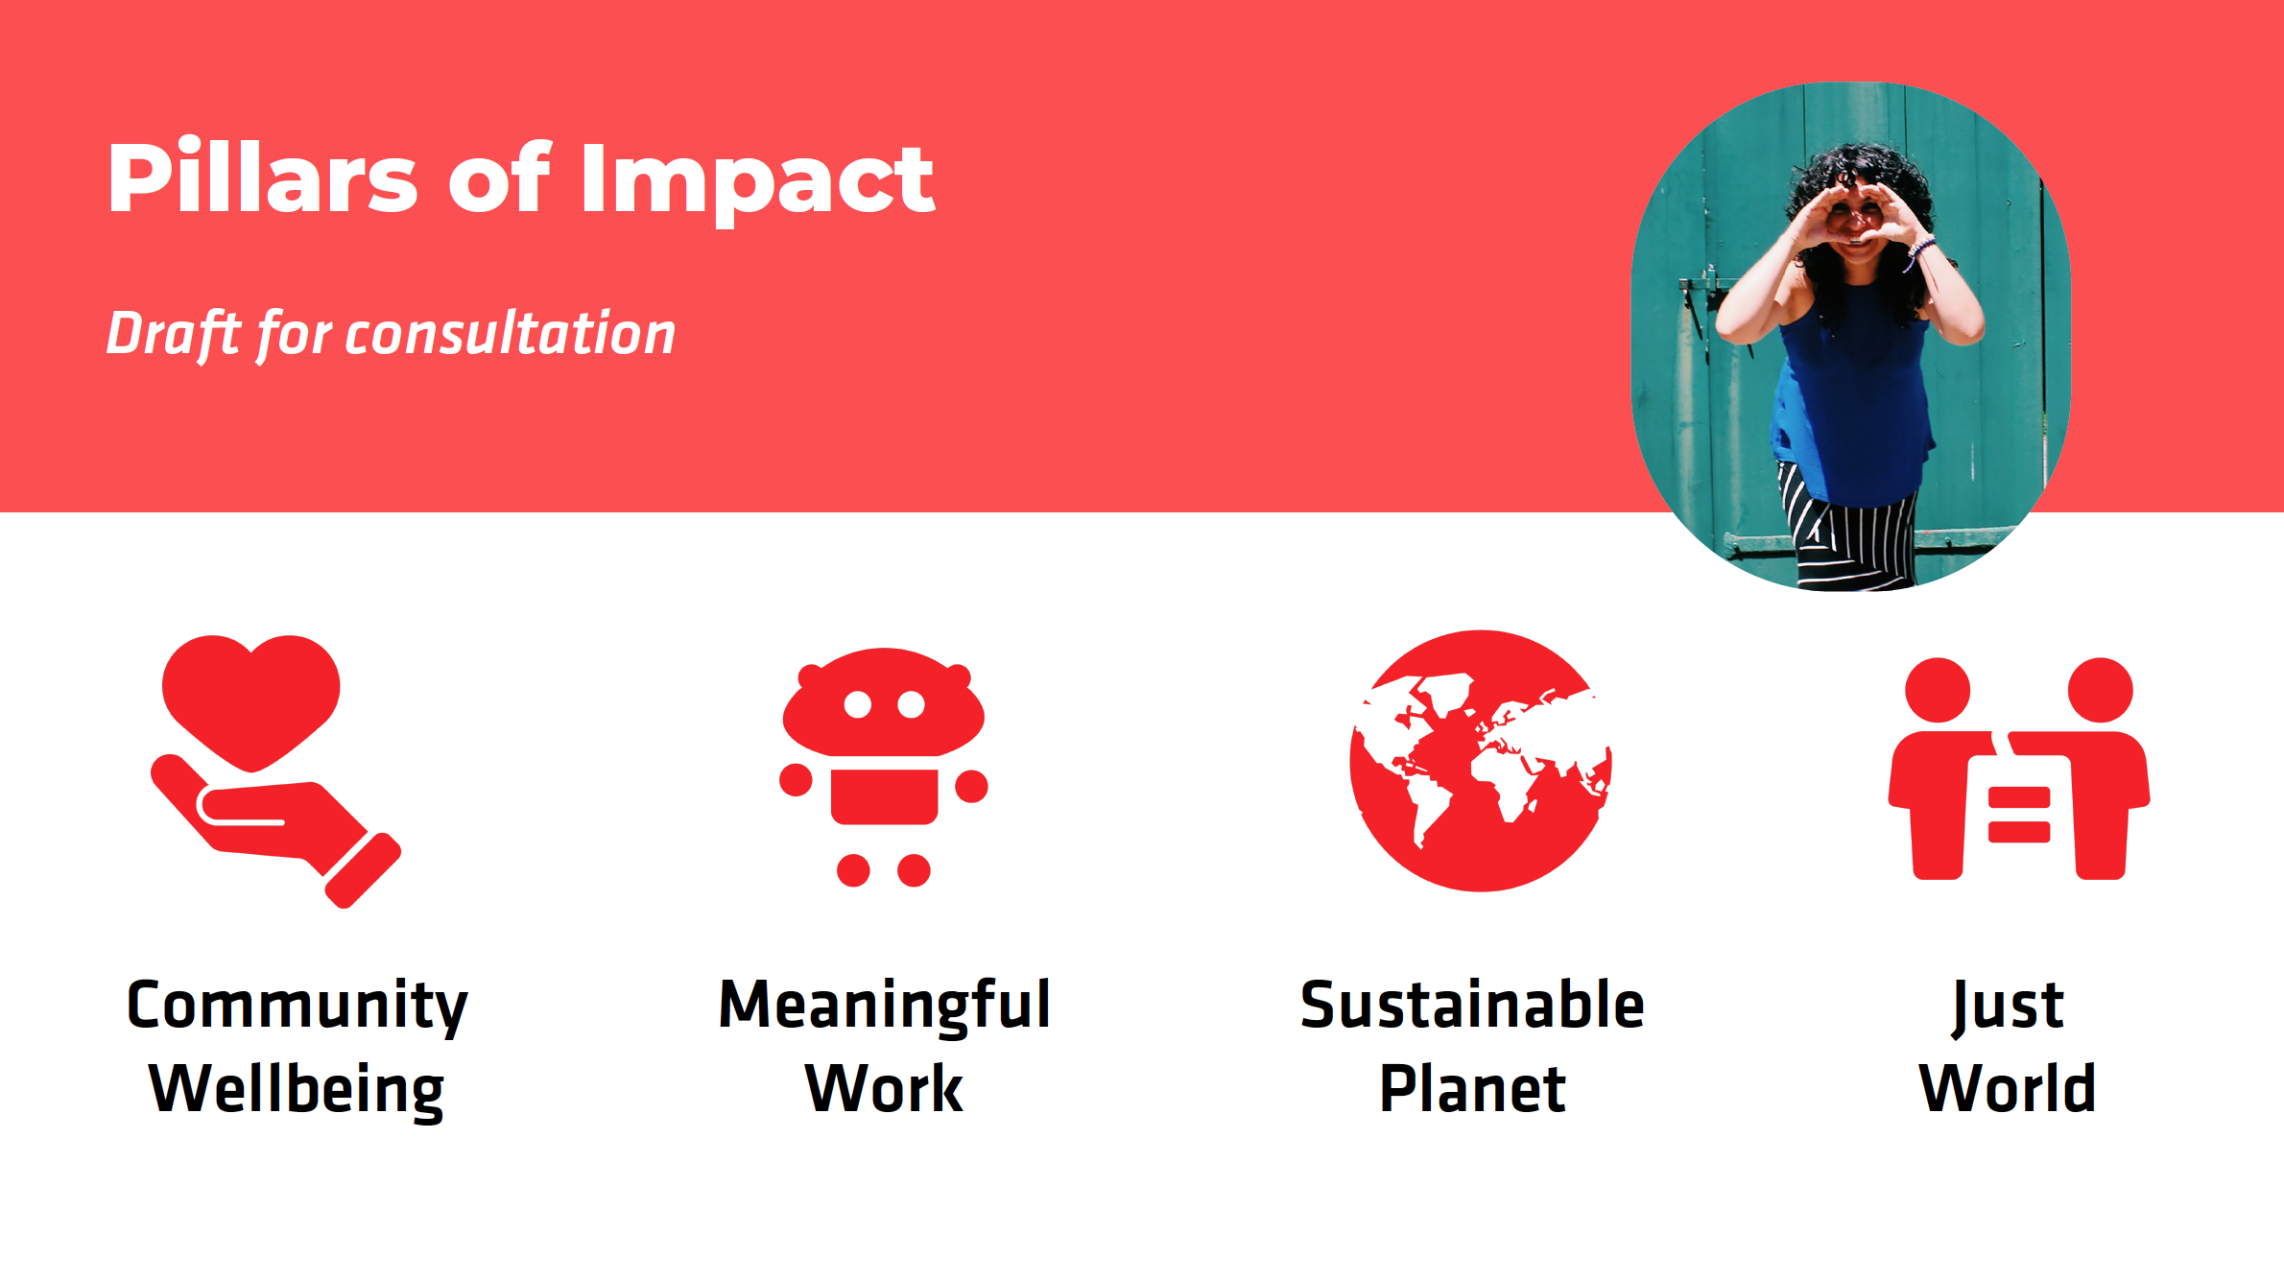

Under each pillar we have identified 3 goals for our work, ensuring that these are also aligned with the United Nations SDGs, National Youth Work outcomes and the Scottish Performance Framework.

**Community Wellbeing**

Creating safe community spaces & reducing isolation

Improving mental, physical and spiritual wellbeing

Improving family relationships

**Meaningful Work**

Improving life & employability skills

Improving & increasing digital literacy

Improving educational attainment

**A Sustainable Planet**

Become a net-zero organisation

Improving sustainability

Increasing community climate activities

**A Just World**

Embed UNCRC in our work

Reducing the poverty related attainment gap

Increasing awareness and action on global inequity

We have aligned with the YMCA global movement in focusing our work around the four YMCA pillars of impact. Under each pillar we have identified three goals for our work, ensuring that these are also aligned with the United Nations SDGs, UNCRC and the Scottish Performance Framework.

